MongoDB Setup

By Nolan Eitzen

For CIS 530 Assignment 5.2

# Setup Page

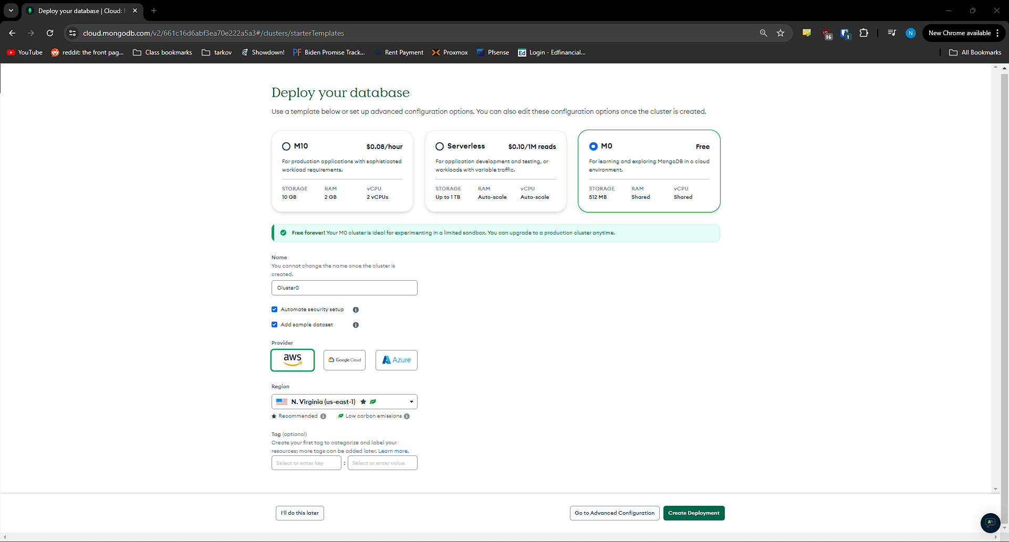

# Project Rename Page

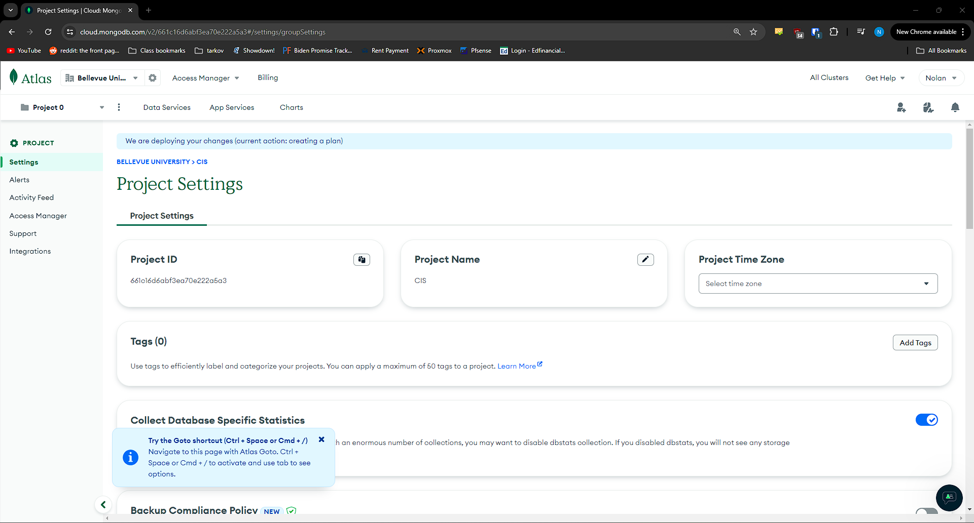

# User Setup

# Network Access Setup

# Collections Page

# Book club Collection

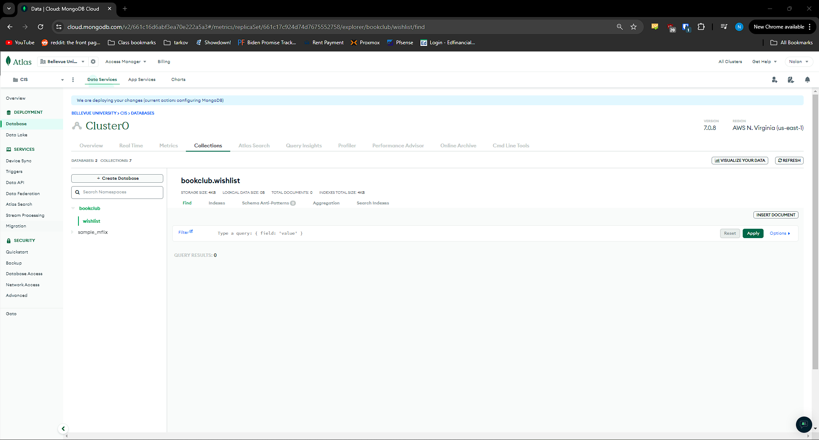

# MongoDB Connection

